Five Knots You Should Know

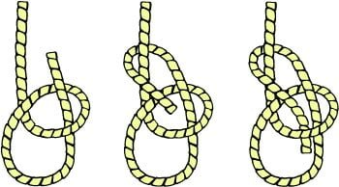
- Square Knot - Most used to tie two ropes together
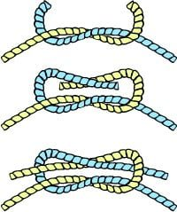
- Bowline - Most commonly used to make a loop

- Sheet Bend - used for tying ropes of different materials together
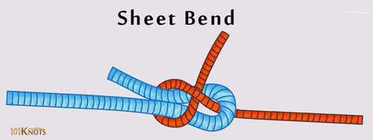

- Double Half-Hitch - used for tying a rope to a post
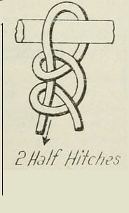
- Tautline - Most used to make a taut, adjustable line for guy lines
