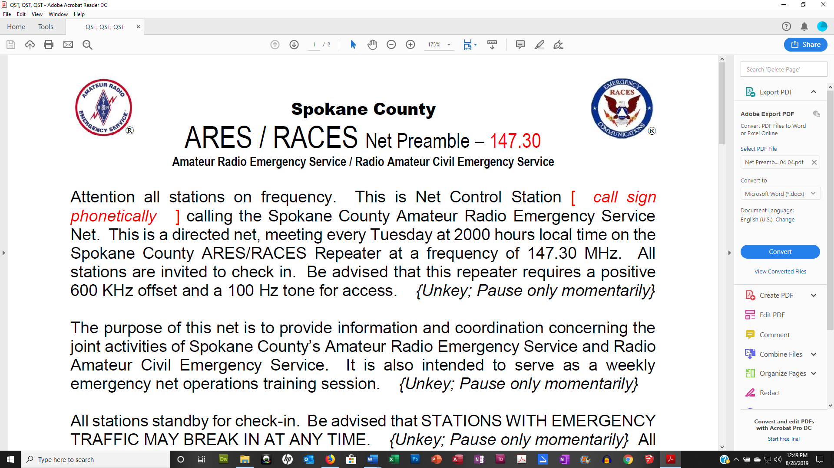
Spokane County
ARES-ACS Simplex Net Preamble
Amateur Radio Emergency Service/Auxiliary Communications System
Note to Net Control: It is important on simplex to repeat back each call sign slowly, phonetically and completely as they check into the net. This is for those stations that others do not hear. That way the whole net knows whose playing and can compare how they are doing across the whole area from net to net or as they improve their antenna system or propagation improves or declines.

At the appointed time:
Attention all stations on frequency. This is Net Control Station {Insert call sign} calling the Spokane County ARES-ACS Net. This is a directed net on this simplex frequency held every fifth Tuesday of the month at 2000 hours local time.

This net normally meets every Tuesday at 2000 hours locale time on the Spokane County ACS Repeater.

All stations are invited to check in. Also, because this is simplex, we will be requesting a readback of the number of stations heard from everyone that checks in. Therefore, please have paper and pencil ready to record the call signs plus the signal strength of each station you hear. There is a roster on the Spokane County ARES website to aid you in recording this information. In addition, you are requested to send your list of stations heard to AG7QP@ARRL.net, who will compile a comprehensive contact report that will be available on our website.

{Unkey; Pause only momentarily}
The purpose of this net is to provide information and coordination concerning the joint activities of Spokane County’s ARES-ACS group. It is also intended to serve as a weekly emergency net operations training session.
Please note that announcements and traffic will be made after this simplex net on the regular repeater frequency. So, at the conclusion of this net, please switch to the Spokane County ACS Repeater.
{Unkey; Pause only momentarily}
All stations standby for check-in. Be advised that STATIONS WITH EMERGENCY TRAFFIC MAY BREAK IN AT ANY TIME.
{Unkey; Pause only momentarily}

All other stations, please observe proper procedure for all transmissions. Visiting stations will be invited to check-in after the call for Spokane County ARES-ACS members. Please state your call sign slowly and phonetically.
{Unkey; pause}

{Establish one or two net control relays if needed}
Net control will periodically call for relays. Please do not volunteer relays until net control has called for them. Also, when operating as a relay, please use call signs so that others who only hear one side of transmissions will understand who is being called. All others please be patient during relays; you might only be hearing one side of the conversation.

Use the separate ARES Roster for the following
This is Net Control Station {Insert call sign} now calling for ARES-ACS officials:
- Spokane County Emergency Coordinator and ACS Officer: {courtesy repeat, if necessary, ask Are there any relays?}
- Spokane County Assistant Emergency Coordinators: {courtesy repeat Are there any relays?}
- ARRL District and Section Officials: {courtesy repeat, Are there any relays?}
- ARES-ACS/ARES/RACES/ACS officials from surrounding counties: {courtesy repeat, Are there any relays?}

This is Net Control Station {Insert call sign}. Standby for Spokane County ARES-ACS member check-in. Check-in will be ordered alphabetically in groups by call sign suffix. When checking in, list all traffic then hold for direction from Net Control. Any station needing to leave the net immediately after checking in, please advise Net Control and wait to be excused. Please remember to state your call sign slowly and phonetically.
Now calling Spokane County ARES-ACS members:
----------------------------------Use Roster to Track---------------------------------
- ALPHA through DELTA {courtesy repeat, Are there any relays?}
- ECHO through INDIA {courtesy repeat, Are there any relays?}
- JULIET through NOVEMBER {courtesy repeat, Are there any relays?}
- OSCAR through SIERRA
- TANGO through ZULU {courtesy repeat, Are there any relays?}

Now calling visiting stations: please respond with your call sign, name and location. {Unkey; pause; cordially confirm visiting check-ins}
Are there any relays? {Unkey; pause}

This is Net Control Station {Insert call sign}, now calling for late or missed check-ins Alpha through Zulu. {courtesy repeat, Are there any relays?}

Any station whose contact information has changed including: email address, call sign, phone number and mailing address please send changes to AG7QP@arrl.net or via the contact form on the spokares.org website.

We will now call for read backs of the number of stations you heard starting with:
{Call each check in for read backs they heard.}

Please note that announcements and traffic will be made after this simplex net on the ACS repeater. So, at the conclusion of this net, please switch to the Spokane County ACS Repeater.

Please send your contact report to AG7QP@ARRL.net, who will compile a comprehensive contact report that will be available on our website.

Good evening and thank you all for checking in. This net meets every Tuesday at 2000 hours local time. This is Net Control Station {Insert call sign} closing the Spokane County ARES-ACS Net at _______ hours, local time.
After the net, send your net report consisting of duration and call signs that checked in to nikreed1@msn.com and AG7QP@arrl.net as soon as you can. Thank you.
After the simplex net, switch to the regular Spokane County ARES-ACS repeater and continue the net as follows:

Attention all stations on frequency. This is Net Control Station {INSERT CALL SIGN HERE} continuing the Spokane County ARES-ACS Net. This is a directed net, meeting every Tuesday at 2000 hours local time on. Because this is the fifth Tuesday of the month, this net started on the ARES simplex frequency in place of our regular net on the Spokane County ACS repeater.
Alternate (if using 146.880 MHz repeater)
The alternate Spokane County ACS Repeater. All stations are invited to check in.
Primary (if using 147.300 MHz repeater)
The Spokane County ACS Repeater. All stations are invited to check in. If we have trouble or this repeater is unavailable, we will switch to the alternate repeater.

First, we will call for check ins by anyone who did NOT check in to the simplex net starting with
- ALPHA through DELTA
- ECHO through INDIA
- JULIET through NOVEMBER
- OSCAR through SIERRA
- TANGO through ZULU
- Any visitors

This is Net Control Station {INSERT CALL SIGN HERE} now calling stations that have listed traffic:
- Starting with… {call each station that checked-in with listed traffic, ask for questions after}
- Stations with contacts: {help arrange contacts off frequency or after net}

This is Net Control Station {INSERT CALL SIGN HERE}, now calling for late or missed check-ins Alpha through Zulu. {courtesy repeat}

Any station whose contact information has changed including: email address, call sign, phone number and mailing address please send changes to any member of the leadership team or via the contact form on the spokares.org website.

Last call for traffic of any kind: {pause, then handle accordingly}

Good evening and thank you all for checking in. This net meets every Tuesday at 2000 hours local time. This is Net Control Station {INSERT CALL SIGN HERE} closing the Spokane County ARES-ACS Net at _______ hours, local time.
After the net, send your net report consisting of duration and call signs that checked in to nikreed1@msn.com and AG7QP@arrl.net as soon as you can.

Thank you

