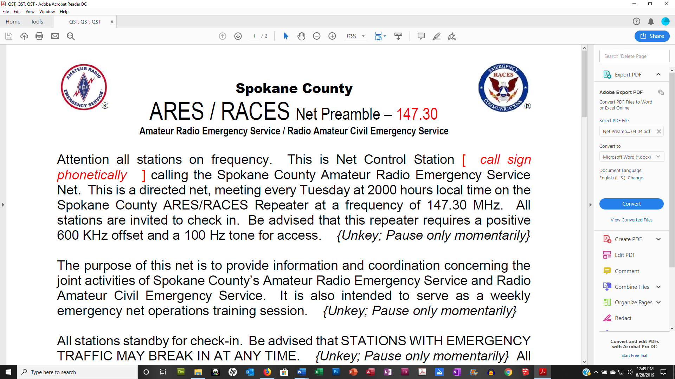
Spokane County
ARES-ACS Net Preamble/Script
Amateur Radio Emergency Service/Auxiliary Communications System

Note for Net Controls: Because there are operators who use cross-band stations to participate in our nets, it is important for the Net Control to take breaks to allow the repeater to tail out, i.e., Unkey; pause, let the repeater drop out. This will allow those who use cross-band stations opportunities to break in.

Please read the following announcement on the air at about 1955 hours:
Attention all stations on frequency. This is Net Control Station {INSERT CALL SIGN HERE}. The Spokane County ARES-ACS Net will start in about five minutes. At that time all stations will be invited to check in as directed by net control
[Only if a second or fourth Tuesday (Winlink Nights) All stations that intend to check in are requested to get paper and pencil for tonight’s Winlink assignment.]

At 2000 hours:
Attention all stations on frequency. This is Net Control Station {INSERT CALL SIGN HERE} calling the Spokane County ARES-ACS Net. This is a directed net, meeting every Tuesday at 2000 hours local time on [the Spokane County ACS Repeater. All stations are invited to check in. If we have trouble or this repeater is unavailable, we will switch to the alternate repeater. All stations are invited to check in.
In months with a fifth Tuesday, this net is held on the Spokane County ARES-ACS simplex frequency in place of our regular net on the Spokane County ACS repeater.
{Unkey; Pause only momentarily}
The purpose of this net is to provide information and coordination concerning the joint activities of Spokane County’s ARES-ACS group. It is also intended to serve as a weekly emergency net training session for those services, to allow participants to test their equipment, verify improvements, and check propagation.
{Unkey; Pause only momentarily}
All stations standby for check-in. Be advised that STATIONS WITH EMERGENCY OR PRIORITY TRAFFIC MAY BREAK IN AT ANY TIME.
{Unkey; Pause only momentarily}

[Read on second and fourth Tuesdays (Winlink Nights) only:
Winlink Assignment will be provided separately
{Unkey; pause, let the repeater drop out}]

All other stations, please observe proper procedure for all transmissions. Visiting stations will be invited to check-in after the call for Spokane County ARES-ACS members. Please state your call sign slowly and phonetically.
{Unkey; pause, let the repeater drop out}

This is Net Control Station {INSERT CALL SIGN HERE} now calling for Spokane County ARES-ACS officials and members: {courtesy repeat after each call}
----------------------------------Use Roster to Track---------------------------------
- Spokane County Emergency Coordinator and ACS Officer:
- Spokane County Assistant Emergency Coordinators:
- ARRL District and Section Officials:
- ARES/RACES/ACS officials from surrounding counties:
This is Net Control Station {INSERT CALL SIGN HERE}. Standby for Spokane County ARES-ACS member check-in. Check-in will be ordered alphabetically in groups by call sign suffix. When checking in, list all traffic then hold for direction from Net Control. Any station needing to leave the net immediately after checking in, please advise Net Control and wait to be excused. Please remember to state your call sign slowly and phonetically.
Now calling Spokane County ARES-ACS members: {courtesy repeat after each call}
Use the roster and confirm each call sign.
- Now calling visiting stations: please respond with your call sign, name and location. {Unkey; pause, let the repeater drop; cordially confirm visiting check-ins}
- Now calling for simplex stations, stations without sub-audible tone capability and crossband stations. We will be listening for your signal on the output of the repeater. FIRST WAIT FOR THE REPEATER TO TAIL OUT BEFORE CHECKING IN. All other stations, please standby and copy for possible relay. When you check in, please state whether you are a simplex or cross-band station. {Unkey; pause, let the repeater drop out and then wait five seconds after the last call.
Are there any relays? {Unkey; pause, let the repeater drop out}

This is Net Control Station {INSERT CALL SIGN HERE} now calling stations that have listed traffic:
- Starting with… {call each station that checked-in with listed traffic, ask for questions after}
- Stations with contacts: {help arrange contacts off frequency or after net}

This is Net Control Station {INSERT CALL SIGN HERE}, now calling for late or missed check-ins Alpha through Zulu. {courtesy repeat}

Any station whose contact information has changed including: email address, call sign, phone number and mailing address please send changes to AG7QP@arrl.net.

[Read on second and fourth Tuesdays (Winlink Nights) only:]
This is a reminder for Winlink capable stations to have paper and pencil. I now turn to (Who has Winlink assignment) for the Winlink Assignment.
Are there any questions?
{Unkey; pause, let the repeater drop out}

Last call for traffic of any kind: {pause, then handle accordingly}

Good evening and thank you all for checking in. This net meets every Tuesday at 2000 hours local time. This is Net Control Station {INSERT CALL SIGN HERE} closing the Spokane County ARES-ACS Net at _______ hours, local time.

After the net, send your net report consisting of duration and call signs that checked in to nikreed1@msn.com and AG7QP@arrl.net as soon as you can.

Thank you

